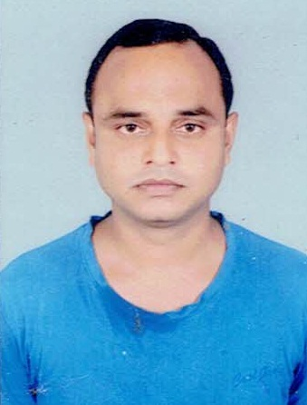

Resume

Pramod Kumar

S/o Late Ramesh Singh
pramod94adrash@gmail.com
Contact Number: +91 8210704719

Position Sought : Office In charge/ Store In charge

Current Industry : Construction

Goal to be achieved:

With my aptitude and experience, I am fully confident to take-up any suitable challenging position in a professional manner. I am dynamic, enthusiastic and posse’s good communication skills. I am looking for a position where I can utilize my skills and experience to advance my career and add value to your esteemed organization.

- Over 7 years total experience in various positions viz. Site In charge / Office In charge with all round responsibilities.

Academic Qualification

  - H.S.C in Art^{s} from Bihar Intermediate Board, Patna, INDIA 2000.
  - S.S.C from Bihar School Examination Board State Board , Patna, INDIA 1998 .

Extra Qualification

- Tally 9.2 from Lord Budha Education Raja Bazar Patna , India.

Professional Experience

- Working at M/S SIDDHIVINAYAK Defenc colony Kankarbagh Patna as a office in-charge from May 2015 to till date.
- Working at AMBIKA BHAWANI DEVELOPARS PVT. LTD. Phulwarisharif Patna as a site in-charge from April 2014 to April 2015.
- Working at DEEP SHEETAL ENGINEERS PVT. LTD.R.K. Puram, Saguna Khagaul Road Danapur as a office in-charge cum Site in-charge from April 2011 to March 2014.

Personnel Information

Name Pramod Kumar

Marital Status Married

Languages English, Hindi
Date of Birth 05 January 1982

Gender Male

Nationality Indian

Permanent Address At + Post – Gundi , P.S. –krishnagadh Dist – Arrah (Bhojpur) Bihar 802313.
Email Address : pramod94adrash@gmail.com

Skill Sets (Personal)

- Excellent communication and coordination with seniors and subordinates.
- Maintaining healthy relationship with the Management. Team worker.
- Maintaining excellent communication and relationship with clients.
- Gaining the trust and confidences of the client. Presales abilities.
- Working under pressure, strenuous and a time sensitive environment.

References:
1. Mr. Niraj Kumar
Managing Director
Deep Sheetal Engineers Pvt. Ltd. Signature
2. Mr. Triloki Nath Sharma
Managing Director
Ambika Bhavani Developers Pvt. Ltd Pramod kumar
3. Amrita Singh
Proprietor
Shiddhivinayak

